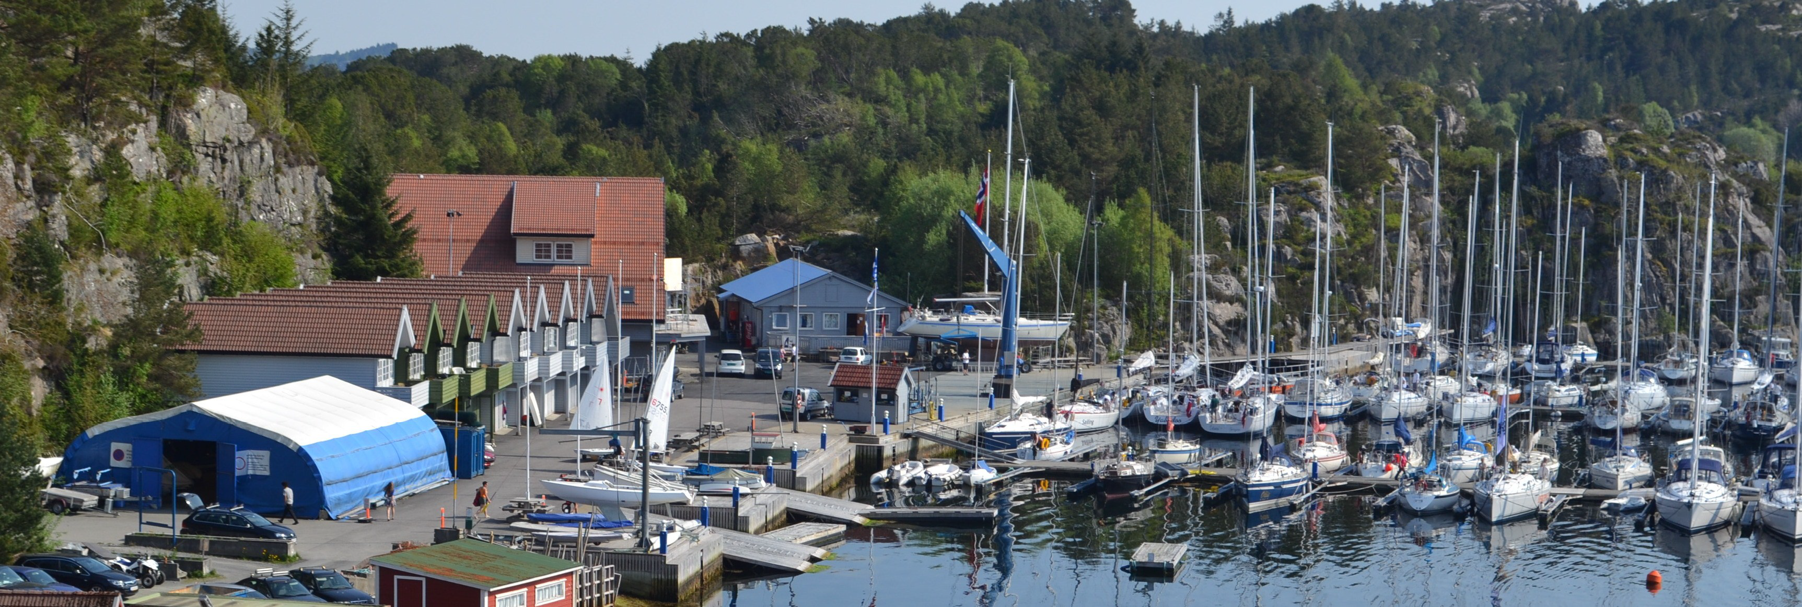

ASKØY SEILFORENING

OPEN NORWEGIAN YNGLING CHAMPIONSHIP

September 5-7. 2014

Notice of Race

- RULES
  - The regatta will be governed by the ”rules” as defined in the Racing Rules of Sailing (RRS), except as changed by the sailing instructions.
  - The ”Spesielle bestemmelser for Norgescup” issued by the Norwegian Yngling Association and ”Regler for Norgesmesterskap” will apply for Norwegian competitors.
  - Prescriptions of the Nordic Sailing Federation and Yngling Class Rules will apply.
  - If there is a conflict between language, the English text will take presedence.

- ADVERTISING
  - Boats may be required to display advertising chosen and supplied by the organizing authority.

- ELIGIBILITY AND ENTRY
  - The regatta is open to all boats of the Yngling class from all nations. The boat must comply with the Yngling Class Rules and be fitted with a valid IYA sticker.
  - The crew shall consist of two or three people stated latest at registration.
  - All sailors shall be member of an ISAF organisation.
  - Entry online via www.seilmagasinet.no. For support, contact race committee.

- FEES
  - Fee is stated in NOK. The fee is NOK 600,-.

- SCHEDULE
  - Registration
All boats: Friday 5 September 1800-2100 and Saturday 6 September 0800-0900 at the regatta office in the club house.
  - Skippers meeting
All race day at 1000.
  - Sailing
Saturday 6 September. First warning signal for the first race 1100.
Sunday 7 September: First warning signal for the first race 1100.
  - There will be a maximum of 10 races. On Sunday, no warning signal will be made later than 1500.

- MEASUREMENTS
  - Each boat must be able to produce a valid class or measurement certificate at any time.
  - The Race Committee may subject boats to random measurement checks.

- SAILING INSTRUCTIONS
  - The Sailing Instructions will latest be available at registration.

- VENUE
  - The venue is located at Askøy Sailing Yacht club, Kollevågen, Askøy.
  - Courses will be sailed in Hauglandsosen

- THE COURSE
  - The courses will be ”windward/leeward courses”.

- PENALTY SYSTEM
  - RRS 44.1 is changed so that the Two-turns Penalty is replaced by the One-turn Penalty.

- SCORING
  - The Low-Point system will apply
  - When fewer than five races have been completed, a boat`s series score will be the total of her race score.
  - When from five to eight races have been completed, a boat`s series score will be the total of her race score excluding her worst score.
  - When nine or mare races have been completed, a boat`s series score will be the total of her race score excluding her worst two scores.

- BERTHING
  - The boats must be placed on the assigned places. Instructions from club officials or from the harbor master must be followed.
  - Boats shall not be hauled out during the regatta from 1000 on the first racing day until the last boat finishes the last race, except with and according to the terms of prior written permission of the race committee.
  - Crane fees for boats participating in the race, are included in the entry fee.
  - Underwater breathing apparatus and plastic pools or their equivalent shall not be used around boats between the preparatory signal of the first race and the end of the regatta.

- PRIZES
  - Prizes for the best 1/3 of total competitors.
  - For Norwegian boats: Medal for the best three teams.

- DISCLAIMER OF LIABILITY
  - Competitors participate in the regatta entirely at their own risk. See rule 4, Decision to Race. The organizing authority will not accept any liability for material or personal injury or death sustained in conjuntion with or prior to, during, or after the regatta.

- INSURANCE
  - Each participating boat shall be insured with valid third-party insurance. Documentation must be presented when required at any time.

- FURTHER INFORMATION
  - Meals and accomodation can be provided at the venue by the host club at low cost. Point of Contact is Sverre Valeur, sverre@nordbye.no, phone: 916 81 000

